Good *morning* / *afternoon* / *evening*.

My name is Karnnumart Iamthammrak Let me introduce our group members. The first one is Mr. Thanasorn Chaiwan.The second one is Mr.Pattawee Sutthichom. The third one is Mr. Bundit Seedow. The last one is Mr.Nirachit Sripradu . We’re a second year student from the Faculty of Engineering, majoring in Computer Engineering.

Today I/we would like to present a summary of a research article entitled “*The ‘Feline Five’: An exploration of personality in pet cats*” written by Carla A. Litchfield and team. The article was published in PLOS ONE in 2017.

Our presentation is divided into *four* parts.

First, we’ll talk about the Introduction.

Next, we’ll describe Materials and methods.

Then, we’ll show you the Results.

And Finally, I’ll talk about the Discussion.

This presentation lasts 15 minutes.

We’d be glad to answer your questions at the end of the presentation.

Let’s *begin* with the first point, the Introduction.

A: Domestic cats have been companion animals for thousands of years. Yet, we know little about typical pet cat behaviour, with most behavioural studies conducted in laboratories, shelters or on free-ranging feral cat colonies.   
This gap in knowledge is problematic since the typical environment for domestic cats is arguably the home. A better understanding of cat personality by means of assessment could help owners improve conditions for their cats at home, thereby supporting the optimal wellbeing of their feline companions.

Investigations of cat personality have focused on either: the continuum of one personality dimension. typically adapting the commonly used approach in human personality research, the Five-Factor Model (FFM). The model is comprised of the dimensions Neuroticism, Extraversion, Openness to Experience, Conscientiousness and Agreeableness.

Some of the methodological limitations or weaknesses of domestic cat personality studies conducted to date include:  
(1) lack of information on length of familiarity between cats and the people rating them .   
(2) lack of acknowledgement of possible influence that researchers may have on cat behaviour when observing them in their homes .  
(3) small sample sizes rated by their owners following recruitment over the Internet .  
(4) insufficient reporting of reliability assessments with inter-rater/observer reliability coefficients the most commonly reported values, conveying varying levels of agreement between raters/observers in their impressions of cat personality trait expression.

This study aimed to analyse personality in a large sample of pet cats,

utilising a personality inventory completed by cat owners about their cats. The study followed on from previous research on felid personality. The research question that this study sought to answer was: how many reliable and interpretable factors depict personality in pet cats and what traits do they represent?

A:I’ve finished explaining the Introduction.

B: Let’s take a look at the next point, Materials and methods.

B: -The study was conducted in New Zealand and South Australia.

-All issues related to participant recruitment and consent were approved by Human Research Ethics Committees.

-Data were collected through an online survey instrument.

-Participants being at least 16 years old and currently living in South Australia, for the Australian survey; being at least 18 years old and currently living in New Zealand, for the New Zealand survey.

-Subjects included 2,802 domestic cats of varying breeds from private homes in South Australia (SA; n = 1,687) and New Zealand (NZ; n = 1,115). This included 1,377 male, 1,387 female and 38 cats of unknown sex, ranging in age from 1–20 years, with a median age of 5 years. Cats under one year of age were excluded and only surveys where respondents had answered all personality items needed for analyses were included.

-The current study utilised a 52-item (variable/trait) survey based on a recent comprehensive Scottish wildcat personality survey.

-The survey included specific definitions alongside each item and 7 points scale.( ‘not at all’ to ‘very much so’)

-This personality survey was part of a larger online survey (using SurveyMonkey).

-Only the cat personality component of the online survey is provided here for analysis. The other parts of the survey are not included.

-Participants were recruited through an open invitation to participate in the project.

-We have payment for participants completed the survey online.

Many survey respondents had not answered all of the cat personality items (*n* = 1,780) as they did not have a cat. The survey responses were also checked for unengaged participants. The remaining sample (*n* = 3,060) was analysed in IBM SPSS Statistics V21.0. The last item ‘eccentric’ was not included as it was found to be an outlier.

B: That’s all I wanted to say about Materials and methods

C: Let’s *turn to* the third point, which is The results.

C:

* The 2,802 cats were owned by 2,291 survey participants, members of the general public of SA and NZ
* Participants were 308 male, 1,850 female and 133 did not answer.
* About 60% of participants were aged between 21 and 50 years.
* [Result]
* 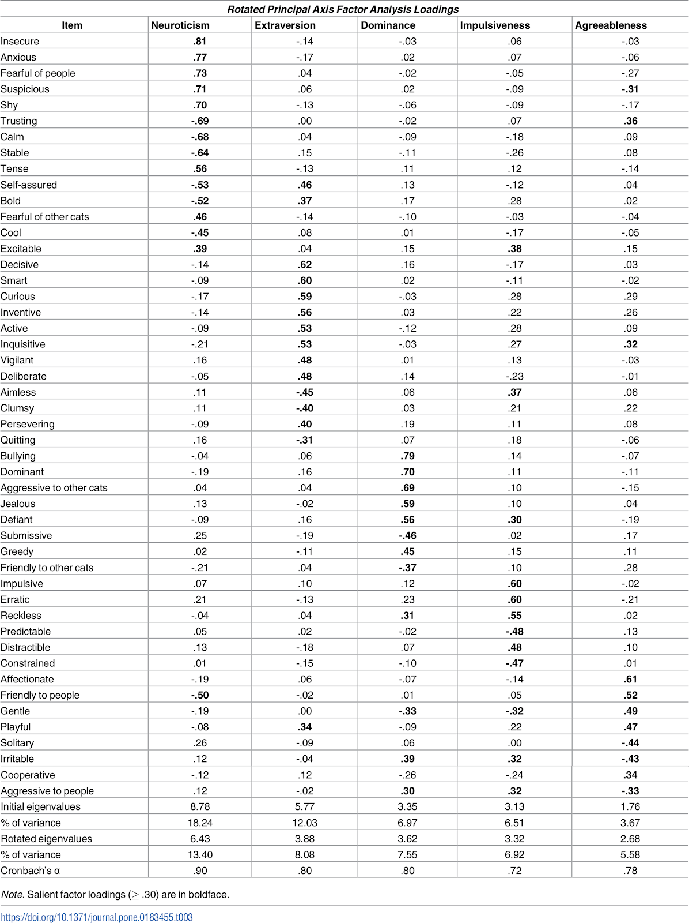

In summary, following the removal of four of the 52 cat personality survey items, the final analysis yielded five distinct factors that depict personality in pet cats from the combined SA

Items with multiple salient loadings were assigned to the factor that had the highest corresponding loading. We refer to this final five-factor solution as the Feline Five.

Thus, factor 1. represents Neuroticism, factor 2. represents Extraversion, factor 3. represents Dominance, factor 4. represents Impulsiveness, and factor 5. represents Agreeableness

The internal consistencies of each of the five factors was assessed using Cronbach's alpha to determine their reliabilities and resulted in a high coefficient of .90 for Neuroticism and acceptable coefficients of .80 for Extraversion and Dominance, and .72, and .78 for Impulsiveness and Agreeableness, respectively.

In summary, the final analysis yielded five distinct factors that depict personality in pet cats from the combined SA and NZ sample and determined the factors were moderately to highly consistent.

C: I’ve finished explaining The results.

D: Now I’ll talk about the last point, which is the Discussion.

D: this study sought to determine the number of reliable and interpretable factors that depict personality in pet cats and analyse what traits the factors represent.

Pet cat personality ratings from SA and NZ revealed five factors with acceptable-high internal consistency, namely: (1) Neuroticism- reflects strongest levels of traits, such as insecure, anxious, fearful of people, suspicious and shy; (2) Dominance- reflects bullying, dominant and aggressive to other cats; (3) Impulsiveness- reflects impulsive, erratic and reckless; and (4) Agreeableness- reflects affectionate, friendly to people and gentle. (5) Extraversion- reflecting Extraversion, including: active, vigilant, curious, inquisitive, inventive, and smart .

The personality profiles of their cats may not only be interesting to cat owners, but may be used to improve welfare or useful for managing multi-cat households, ideally before obtaining a new cat.

Future research could aim to have a more representative sample by setting target sex/gender ratios aligned with population data. Finally, not asking raters how long they had known the cats prior to rating their personalities may also be a limitation to the validity of the measure.

D: I’ve finished talking the Discussion. That brings us to the end of our presentation.

E: Let me just summarize the main points I/we’ve just presented.

First, we talked about the Introduction of our study. We would like to have a better understanding of cat personality by analyse personality in a large sample of pet cats using the Five-Factor Model of Human Personality and adapted it to cats. We also talked about our lack of information, bias and small sample size problem.

Second, we briefly inform you about Materials and methods. We collected all data via online survey from participant in South Australia and New Zealand. A survey include 52 item each rate by 7 point scale.

Then we showed you the Result. We’ve got the data from 2,802 cats that were owned by 2,291 survey participants, members of the general public of SA and NZ. And from the 52 item in survey, we assigned them to the factor that had the highest corresponding loading. We refer to this final five-factor solution as the Feline Five.

the final analysis yielded five distinct factors that depict personality in pet cats were moderately to highly consistent.

Lastly, we talked about the Discussion. We’ve got five factor of cat’s personality are as follows; Neuroticism ,Dominance ,Impulsiveness ,Agreeableness and Extraversion. This cat’s personality may not be interesting to cat’s owner but may be used to improve welfare or useful for managing multi-cat households.

E: Thank you very much for your kind attention. Please feel free to ask questions or give comments.

\*\*\*\*\*\*\*\*\* Q&A

E: We’d like to thank you again for your kind attention.